CCC

New Generation Platform

IOP-AM1 AND FTC-AM1

Hardware Design Document
Rev-1.0

16th September 2011

Ownership Disclaimer
This document contains proprietary and confidential material that is the sole property of Compressor Controls Corporation. The information contained herein is intended for internal use by Compressor Controls Corporation employees and is not intended for distribution outside of the company. As an unpublished work of trade secrets, the recipient shall keep this document confidential. Any re-use, copying, or distribution, either in whole or in part, of this material without the express written consent of Compressor Controls Corporation is strictly forbidden.
Copyright © 2011 by Compressor Controls Corporation. All rights reserved.

Revision History

Rev. | Date | Revised By | Change Description
1.0 | 16-Sep-2011 | Muthuvelu.D | Initial Release

Approvals

Approved by: Date: _____________

TABLE OF CONTENTS

1 Introduction 6
1.1 Purpose 6
1.2 Audience 6
1.3 Scope 6
1.4 Acronyms 6
1.5 References 6
2 General Description 7
2.1 Board features 8
2.2 Implementation block diagram 9
2.3 Description of functional Blocks 10
2.3.2 Power Architecture 10
2.3.2 Microcontroller Daughter Board 11
2.3.3 Analog input 11
2.3.4 Analog output 14
2.3.5 CPLD 14
2.3.6 HART Modem 15
2.4 Front Panel Indicator LEDs 24
3 CAD Tools 25
3.1 Schematic Design Tool 25
3.2 Board Layout Design 25
4 PCB Details 25
4.1 PCB Stack-up 25
5 Connectors 26
5.1 IOP – AM1 to Backplane 26
5.2 IOP-AM1 to MPC5534 Daughter board 26
5.3 FTC – AM1 to Backplane 26
5.4 FTC – AM1 (Terminal Blocks) 26
5.5 IOP-AM1 BACKPLANE SIGNALS 27
5.6 FTC-AM1 BACKPLANE SIGNALS 31

TABLE OF FIGURES

Figure 1: IOP-AM1 to FTC 7
Figure 2: IOP-AM1 BLOCK DIAGRAM 9
Figure 3: Block Diagram of Power architecture 10
Figure 4: AD629 11
Figure 5: Analog MUX 12
Figure 6: Scaling and offset adjustment 13
Figure 7: Analog outputs 14
Figure 8: Frequency Shift Keying (FSK) 15
Figure 9: Two Communication Channels 16
Figure 10: Primary and Secondary Masters 17
Figure 11: Point-to-Point Configuration 17
Figure 12: Multidrop Configuration 18
Figure 13: HART Master Interface Circuit 19
Figure 14: Capacitive coupling 21
Figure 15: HART Implementation at analog input side 21
Figure 16: HART Slave Interface Circuit 22
Figure 17: HART Implementation at analog output side 23
Figure 18: Front Panel Indicator LEDs 24
Figure 19: PCB Stack-up 25

Introduction

Purpose
The purpose of this document is to describe the hardware design details of the IOP-AM1 and FTC-AM1. The document is prepared based on product requirement specifications and hardware requirement specifications prepared for IOP-AM1 and FTC-AM1.

Audience
The intended users of this document are hardware developers, software developers, test engineers, project leaders / program managers and management of Mindteck and Compressor Controls Corporation.

Scope
The scope of this document is to describe the hardware design details of the IOP-AM1 and FTC-AM1. It includes the components chosen, power consumption, layout guidelines and all other aspects of the design.

Acronyms
Acronym | Definition
NGP | New Generation Platform
IOP-AM1 | Input / Output Processor Analog module
FTC-AM1 | Field Termination Card Analog module
NV-RAM | Non volatile - RAM
HART | Highway addressable remote transducer

References
[1] Detailed Functional Specification for NGP Hardware, Part 1, Rev-3
[2] System Study for New Generation Platform Electronics and Bring-up, Rev-1

General Description

IOP ANALOG (IOP-AM1 AND FTC-AM1) are used for processing analog signals (4 to 20mA).There will be a maximum of 6 pairs (A,B Duplex) in NGP system. Each board has the capability to handle 12 analog inputs and 4 analog outputs with HART protocol support.

FTC-AM1-These ate the field terminal cards where all the field loads are connected to. These are electrically interfaced to IOP-AM1. The number of FTC in NGP system is same as the number of IOP pairs.

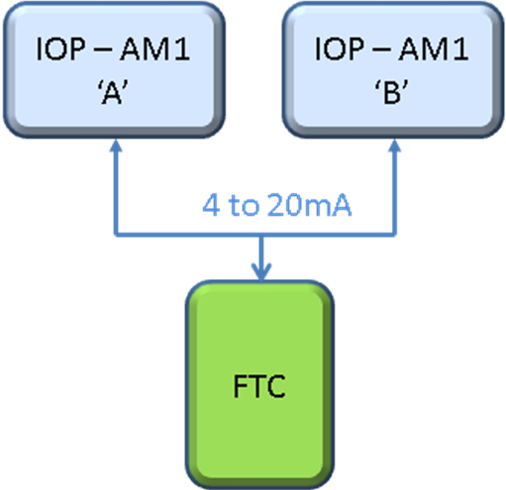

Figure 1: IOP-AM1 to FTC

Board features

IOP-AM1 card has the following features

- Freescale processor MPC5534 based daughter board.
- Ether-CAT (ET1100) bus communications.
- Supports general board diagnostics (Voltage, temperature)
- Hot-swap capability
- Development / test port facility (JTAG, Nexus, logic analyzer etc)

- Analog Inputs (12 No’s)

- Isolated to each others.
- Resolution: 16-bit minimum
- Accuracy (0.1%)
- SPI EEPROM for calibration data
- Indication LED’S
- Ability to extract HART information from all signals and provide to external systems

- Analog Outputs (4 No’s)

- Isolated to each others.
- Resolution: 16bit minimum
- Accuracy (0.1% minimum)
- Verification/Diagnostics of card functionality
- Ability to extract HART information from all signals and provide to external systems
- Duplex Switching
- Indication LED’S
- Ability to extract HART information from all signals and provide to external systems

FTC-AM1 card has the following features

- Three channels - External OR Loop powered options.
- Three channels - 4-20 mA OR 1-5V, switchable at FTC 250E resistor.
- Nine channels – Loop powered only.

Implementation block diagram
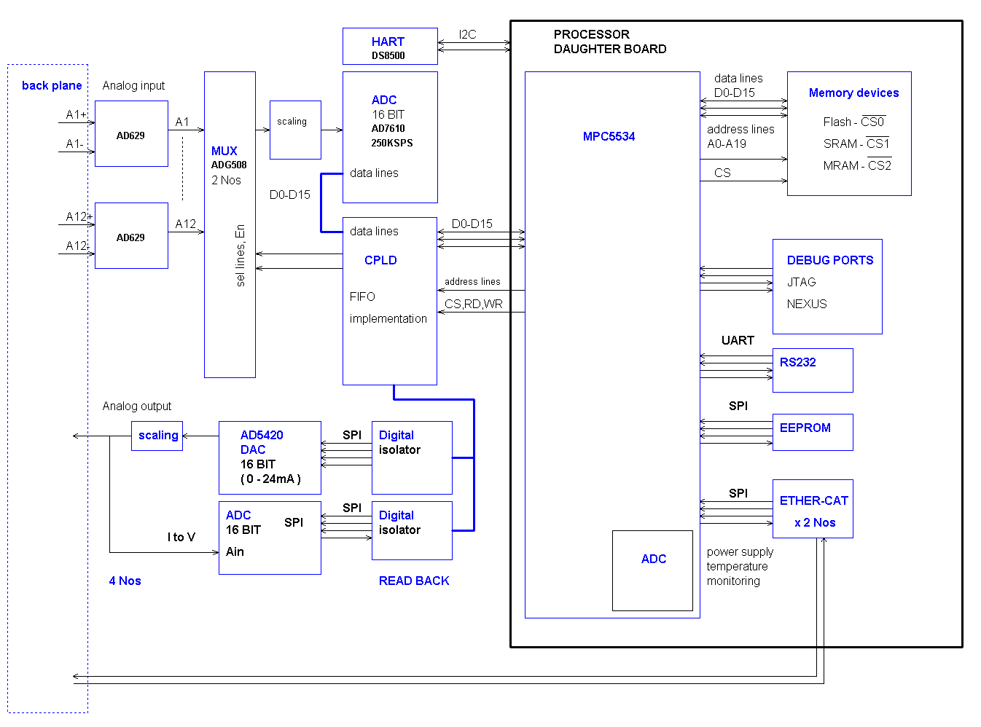
Figure 2: IOP-AM1 BLOCK DIAGRAM

Description of functional Blocks

2.3.2 Power Architecture

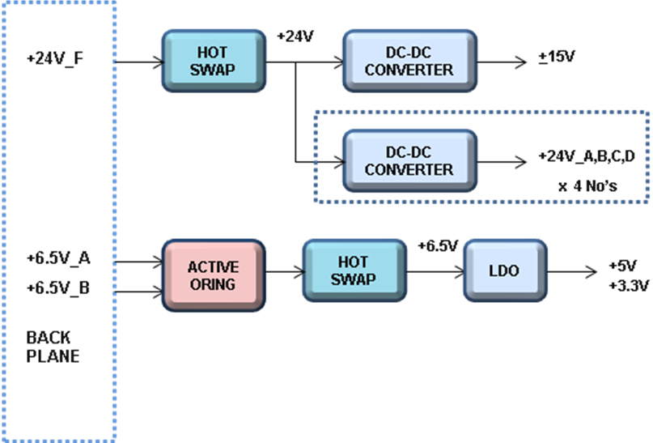

Figure 3: Block Diagram of Power architecture

- Both 24V_F and +6.5V A and B (Active oring) power supplies are hot swappable.
- Enabled through short pin (AirMax connectors).
- +24V is used for generating +15V for ADC section (analog inputs) and 4 No’s of isolated 24V_A, B, C, D are generated (analog outputs).
- +5V and +3.3V (Digital Supplies) are generated from +6.5V LDO.

2.3.2 Microcontroller Daughter Board

Freescale MPC5534 microcontroller based board with memory interfaced SRAM- 512K x16, MRAM- 1Mx16, NOR FLASH – 512K x16 and SPI EEPROM.
A CPLD is used for health monitoring and duplex switching. The daughter board is interfaced to IOP-AM1 CPLD through EBI bus.16 bit data bus and 13 bit address lines. Voltage, temperature and other diagnostics are performed by MPC5534 processor. Supports ether-cat (ET1100) bus communications.

2.3.3 Analog input

Analog inputs (12 pairs) coming from FTC are isolated to each other (isolation voltage: +250V) using AD629. (Converts differential to single ended).

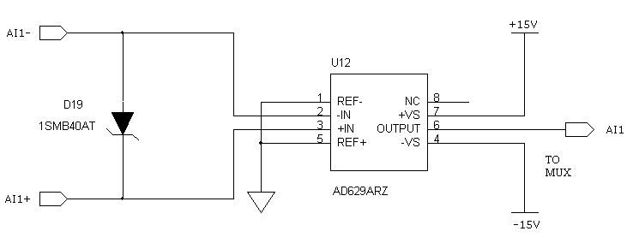

Figure 4: AD629

After AD629 12 analog signals are muxed through two 8 channel analog mux’s (ADG508).The channel is chosen by CPLD. The first and last channels are connected to voltage references for testing.

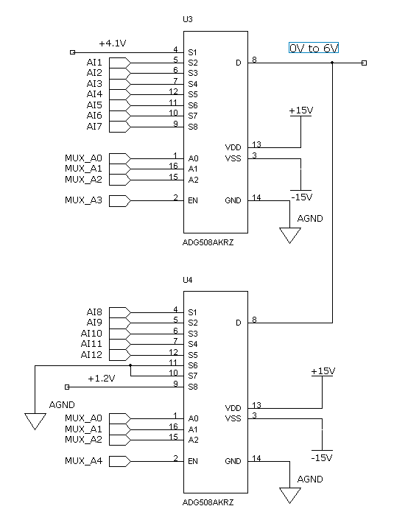

Figure 5: Analog MUX

Scaling and Offset adjustment

Analog input offset can be adjusted (+100mV) using R5 potentiometer and input is scaled to ADC input range.

For 0 to 24mA, ADC input will be 0 to 9.6V.

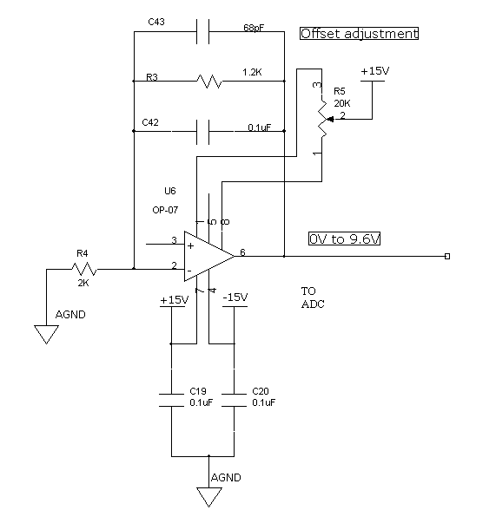
Figure 6: Scaling and offset adjustment

ADC

16-bit 250KSPS AD7610 is used with parallel interface to CPLD in order to implement FIFO (To achieve 1mS conversion time).

2.3.4 Analog output

Four channels of isolated analog outputs are implemented (0 to 24mA capable) using AD5420 (16-bit serial DAC).These DAC’S are controlled through CPLD.
The output is read back using ADS8341 (16-bit serial ADC).

All SPI lines controlling ADC and DAC are isolated using ADuM3210 and ADuM3211 i-couplers.

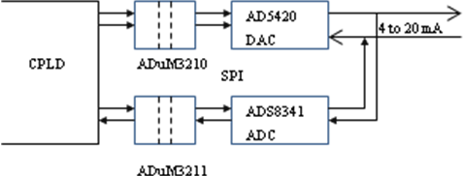

Figure 7: Analog outputs

2.3.5 CPLD

- Part No: EPM2210F256I5N
- MAX II CPLD 2210 Logic elements with 204 I/O’s support.
- Package 256-FBGA
- Functions
- Read ADC Channels and store the data in internal FIFO
- Control DAC’S
- Control HART mux channels.
- Control front panel LEDs.
- Communicate with MPC5534 through parallel 13-bit address and 16-bit data.

2.3.6 HART Modem

Introduction

“HART” is an acronym for Highway Addressable Remote Transducer. The HART Protocol makes use of the Bell 202 Frequency Shift Keying (FSK) standard to superimpose digital communication signals at a low level on top of the 4-20mA.
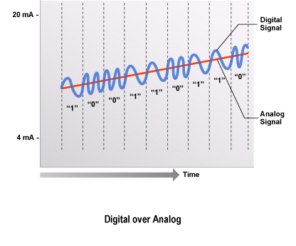
Figure 8: Frequency Shift Keying (FSK)
This enables two-way field communication to take place and makes it possible for additional information beyond just the normal process variable to be communicated to/from a smart field instrument. The HART Protocol communicates at 1200 bps without interrupting the 4-20mA signal and allows a host application (master) to get two or more digital updates per second from a smart field device. As the digital FSK signal is phase continuous, there is no interference with the 4-20mA signal.
HART technology is a master/slave protocol, which means that a smart field (slave) device only speaks when spoken to by a master. The HART Protocol can be used in various modes such as point-to-point or multidrop for communicating information to/from smart field instruments and central control or monitoring systems.
HART Communication occurs between two HART-enabled devices, typically a smart field device and a control or monitoring system. Communication occurs using standard instrumentation grade wire and using standard wiring and termination practices.
The HART Protocol provides two simultaneous communication channels: the 4-20mA analog signal and a digital signal. The 4-20mA signal communicates the primary measured value (in the case of a field instrument) using the 4-20mA current loop - the fastest and most reliable industry standard. Additional device information is communicated using a digital signal that is superimposed on the analog signal.
The digital signal contains information from the device including device status, diagnostics, additional measured or calculated values, etc. Together, the two communication channels provide a low-cost and very robust complete field communication solution that is easy to use and configure.
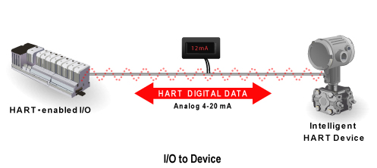
Figure 9: Two Communication Channels
The HART Protocol provides for up to two masters (primary and secondary). This allows secondary masters such as handheld communicators to be used without interfering with communications to/from the primary master, i.e. control/monitoring system.
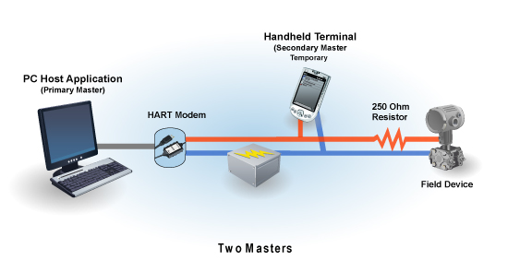
Figure 10: Primary and Secondary Masters
The HART Protocol permits all digital communication with field devices in either point-to-point or multidrop network configurations:
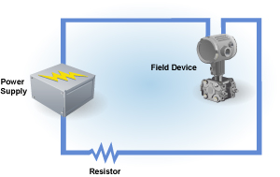
Figure 11: Point-to-Point Configuration
Multidrop Configuration
There is also an optional "burst" communication mode where a single slave device can continuously broadcast a standard HART reply message. Higher update rates are possible with this optional burst communication mode and use is normally restricted to point-to-point configuration.

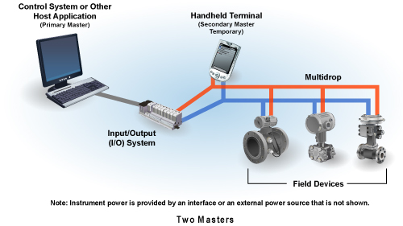
Figure 12: Multidrop Configuration

HART Implementation at analog input side

Master Device
The HART Master interfaces to the network as a voltage source, as illustrated in simplified form in Figure 13. The network is driven by a low output impedance (600 ohm or less) voltage amplifier circuit that can be switched to a high impedance state using RTS. The output of the voltage amplifier needs to be high impedance while the HART Master receives, to insure high input impedance for the receiver.

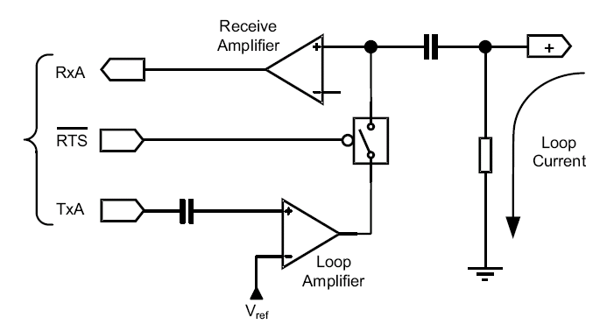
Figure 13: HART Master Interface Circuit

Transmitting the HART Signal
During a HART message transmission from the Master, the output impedance of the voltage source is quite low (0 −600 ohm). However during reception of a HART message, the input impedance of the receive section must be quite high. Therefore, the transmitter section must be disabled when not active (nRTS = “High”).
Several methods can be used to achieve a high output impedance of the transmitter while nRTS is inactive. One method is choosing an op−amp with an “active low” current programming resistor that will basically “turn off” the op−amp during receive operations. A second method can be implemented with a correctly biased discrete FET in series with the output stage. Lastly, a discrete solid state relay with characteristically low “on resistance” can be used.
All three above techniques will provide an adequate solution for the impedance requirements. However, only the third solution will allow proper circuit operation per the “bit−error−rate” requirements and does not need to be powered by a dual supply
Under worse case conditions, a transmitter could dynamically change from 4 − 20 mA and a HART Master could have as much as 1K ohm of loop resistance. This results in (20 – 4)10−3 x 1.103 = 16 V p−p low frequency carrier with HART super imposed. The transmit switch must be designed to prevent this 16 V p−p signal from sinking current through the HART transmitter’s output stage. Any clipping of the 16 Vp−p signal through the HART transmitter or the use of transient suppressors will result in the clipping of the superimposed HART signal. The last solution will block and not clip the 16 Vp−p process signal and will not corrupt the input impedance. The third solution can be implemented easily as shown in Figure 13.
Receiving the HART Signal
All HART receivers require non−disruptive coupling to the network current loop. This connection can be made with capacitive or galvanic coupling without corruption of the process loop current.
The master can be connected across the field instrument or the current sense resistor regardless of the polarity or grounding configuration
The current sense resistor is considered an integral part of a HART Master. In operation, a HART message response from a Slave is superimposed on the 4−20 mA current loop. The Slave’s 1 mA p−p HART signal is dropped across the Master’s sense resistor. For a typical sense resistor of 250 ohm, one can expect 250 mVp−p signal extracted from a HART Slave device. A HART Master can have a sense resistor ranging from 230 ohm to 600 ohm.
A HART Master must be able to receive voltage signals that are developed across the sense impedance. In addition, it must be able to apply a transmit signal across the current sense impedance. In some cases the Master will signal across the field device as well. In all cases, the presence of the HART Master must not disrupt the analog signaling of the process loop. Therefore, the HART signals must be non−intrusively coupled from the current sense resistor to the Master through one of the various coupling techniques.
Coupling to the network is most commonly done with capacitors and transformers. The simplest form of capacitor coupling is used as shown.
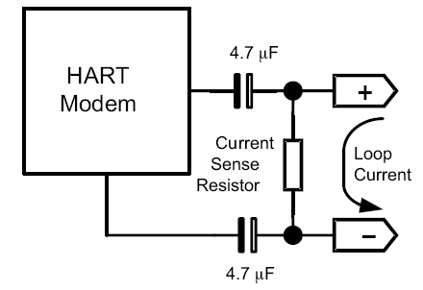
Figure 14: Capacitive coupling
At analog input side two differential analog mux are used for 12 inputs. The select lines are controlled by CPLD. The MPC5534 controls the HART modem through SC16IS750 I2C to UART (full modem) converter.
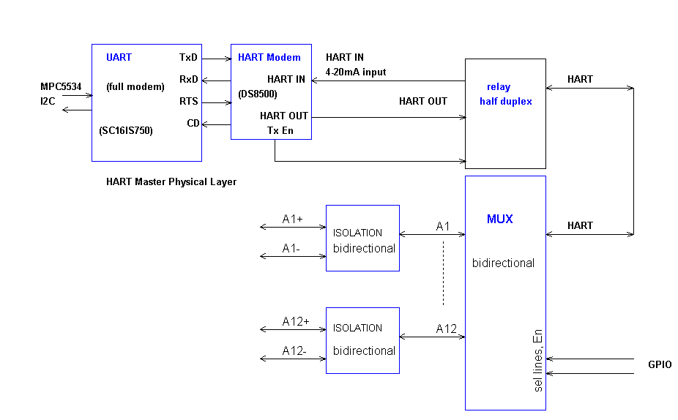
Figure 15: HART Implementation at analog input side
HART Implementation at analog output side

Slave Device
The Slave interface to the network is typically a current regulator, as illustrated in simplified form in Figure 16. Its output current is controlled by varying a much smaller current into an op−amp summing junction. This junction is a convenient point at which to sum the analog and digital signals, thereby achieving superposition of the digital signal onto the analog. The digital transmit signal (TxA) is capacitively coupled into the summing junction, to preserve DC accuracy of the 4−20 mA analog signal. Also shown in Figure 19 is the receive path, consisting of a capacitor from the collector of the current regulator transistor to a high−impedance amplifier. Both the receive amplifier and the transmit current source should present a high impedance (greater than 100K ohm).
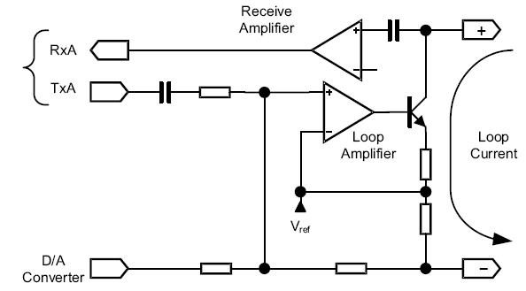
Figure 16: HART Slave Interface Circuit
Transmitting the HART Signal
The amplitude of TxA is nominally 500 mVp−p. The HART Physical Layer requires the Slave to modulate the loop with a 1 mA p−p signal. The amplitude of modulation of the loop current will have to be adjusted before the amplifier in the current loop regulator or at the regulator itself.
It is recommended that the amplitude can be adjusted with voltage gain circuits. Using a small series capacitance to attenuate the signal may cause distortion of the transmitted signal.
Receiving the HART Signal
All HART receivers require non−disruptive coupling to the network current loop. This connection can be made with capacitive or inductive coupling without corruption of the process loop current. Typically a HART Slave uses a small value (2.2 nF) capacitor to couple an adequate signal level to the receive filter.
Analog outputs 4 nos isolated to each other are implemented for HART slave. MPC5534 controls HART modem through isolated I2C (ADuM1250).
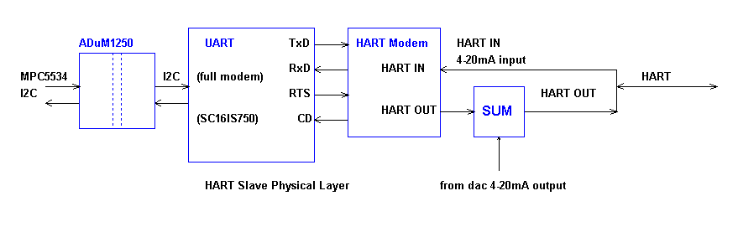
Figure 17: HART Implementation at analog output side

Front Panel Indicator LEDs

Name | Controlled By | Indicators
CCC LOGO | SW | 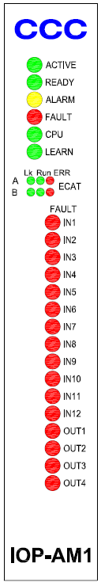
ACTIVE | SW
READY | SW
ALARM | SW
FAULT | SW
CPU | SW
LEARN | SW
ETHER1-LINK | HW
ETHER1-RUN | HW
ETHER1-ER | SW
ETHER2-LINK | HW
ETHER2-RUN | HW
ETHER2-ER | SW
IN1 | SW
IN2 | SW
IN3 | SW
IN4 | SW
IN5 | SW
IN6 | SW
IN7 | SW
IN8 | SW
IN9 | SW
IN10 | SW
IN11 | SW
IN12 | SW
OUT1 | SW
OUT2 | SW
OUT3 | SW
OUT4 | SW

Figure 18: Front Panel Indicator LEDs

CAD Tools

Schematic Design Tool

Schematic entry is done PADS LOGIC 9.3.

Board Layout Design

PCB is designed in PADS LAYOUT 9.3.

PCB Details

No of layers : 8 with impedance controlled board.

PCB Stack-up

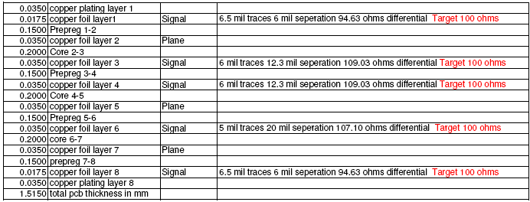

Figure 19: PCB Stack-up

Connectors

IOP – AM1 to Backplane

Make | Part No | Description
FCI | 10045267-111LF | 72-PIN Air-Max
FCI | 10028917-001LF | 4-PIN Power connector
FCI | 10045597-107LF | GUIDE PIN

IOP-AM1 to MPC5534 Daughter board

Make | Part No | Description
Samtec | QTE-040-02-X-D-A | 80-PIN,Male Shroud Contacts

FTC – AM1 to Backplane

Make | Part No | Description
FCI | 10052838-101LF | 96-PIN Air-Max
FCI | 10045597-107LF | GUIDE PIN

FTC – AM1 (Terminal Blocks)

Make | Part No | Description
FCI | 20020107-H121A01LF | 12-PIN Terminal block

IOP-AM1 BACKPLANE SIGNALS

Backplane Connector Pins Naming on IOP-AM1
Connector 1 :
Pin No. | Signal Name | Description
A1 | AI1+ | IO Pair between IOP and FTC
B1 | AI1- | IO Pair between IOP and FTC
C1 | AGND | Analog ground
D1 | AI2+ | IO Pair between IOP and FTC
E1 | AI2- | IO Pair between IOP and FTC
F1 | AGND | Analog ground
G1 | AI3+ | IO Pair between IOP and FTC
H1 | AI3- | IO Pair between IOP and FTC
I1 | AGND | Analog ground
A2 | AGND | Analog ground
B2 | AI4+ | IO Pair between IOP and FTC
C2 | AI4- | IO Pair between IOP and FTC
D2 | AGND | Analog ground
E2 | AI5+ | IO Pair between IOP and FTC
F2 | AI5- | IO Pair between IOP and FTC
G2 | AGND | Analog ground
H2 | AI6+ | IO Pair between IOP and FTC
I2 | AI6- | IO Pair between IOP and FTC
A3 | AI7+ | IO Pair between IOP and FTC
B3 | AI7- | IO Pair between IOP and FTC
C3 | AGND | Analog ground
D3 | AI8+ | IO Pair between IOP and FTC
E3 | AI8- | IO Pair between IOP and FTC
F3 | AGND | Analog ground
G3 | AI9+ | IO Pair between IOP and FTC
H3 | AI9- | IO Pair between IOP and FTC
I3 | AGND | Analog ground
A4 | AGND | Analog ground
B4 | AI10+ | IO Pair between IOP and FTC
C4 | AI10- | IO Pair between IOP and FTC
D4 | NC
E4 | IOP_E4 | E4 Short Pin
F4 | NC
G4 | NC
H4 | AI11+ | IO Pair between IOP and FTC
I4 | AI11- | IO Pair between IOP and FTC
A5 | AI12+ | IO Pair between IOP and FTC
B5 | AI12- | IO Pair between IOP and FTC
C5 | AGND | Analog ground
D5 | NC | IO Pair between IOP and FTC
E5 | NC
F5 | NC
G5 | AOUT1+ | IO Pair between IOP and FTC
H5 | AOUT1- | IO Pair between IOP and FTC
I5 | GND_A
A6 | GND_B
B6 | AOUT2+ | IO Pair between IOP and FTC
C6 | AOUT2- | IO Pair between IOP and FTC
D6 | GND_C
E6 | AOUT3+ | IO Pair between IOP and FTC
F6 | AOUT3- | IO Pair between IOP and FTC
G6 | NC
H6 | NC
I6 | NC
A7 | AOUT4+ | IO Pair between IOP and FTC
B7 | AOUT4- | IO Pair between IOP and FTC
C7 | GND_D
D7 | NC
E7 | NC
F7 | NC
G7 | NC
H7 | NC
I7 | NC
A8 | NC
B8 | NC
C8 | NC
D8 | NC
E8 | NC
F8 | NC
G8 | NC
H8 | NC
I8 | NC
Connector 2 :
Pin No. | Signal Name | Description
A1 | NC
B1 | NC
C1 | NC
D1 | NC
E1 | AGND | Analog ground
F1 | AGND | Analog ground
G1 | AGND | Analog ground
H1 | AGND | Analog ground
I1 | NC
A2 | NC
B2 | NC
C2 | NC
D2 | NC
E2 | NC
F2 | NC
G2 | NC
H2 | NC
I2 | +24V_F | Filtered 24V supply
A3 | +24V_F | Filtered 24V supply
B3 | +24V_F | Filtered 24V supply
C3 | +24V_F | Filtered 24V supply
D3 | +24V_F | Filtered 24V supply
E3 | +24V_F | Filtered 24V supply
F3 | +24V_F | Filtered 24V supply
G3 | Board_ID1 | FTC Board ID 1
H3 | Board_ID2 | FTC Board ID 2
I3 | Board_ID3 | FTC Board ID 3
A4 | Board_ID4 | FTC Board ID 4
B4 | IOP_SLOT_ID1
C4 | IOP_SLOT_ID2
D4 | IOP_SLOT_ID3
E4 | DGND | DGND
F4 | IOP_SLOT_ID4
G4 | CLEAR
H4 | IOP_SHARE_1
I4 | IOP_SHARE_2
A5 | IOP_SHARE_3
B5 | IOP_SHARE_4
C5 | PEER_CONTROL
D5 | NC
E5 | NC
F5 | DGND | DGND
G5 | NC
H5 | NC
I5 | DGND | DGND
A6 | AnB
B6 | NC
C6 | NC
D6 | DGND | DGND
E6 | NC
F6 | NC
G6 | DGND | DGND
H6 | NC
I6 | NC
A7 | IES-B_IOP+ | Receive data from IES-B
B7 | IES-B_IOP- | Receive data from IES-B
C7 | DGND | DGND
D7 | NC
E7 | NC
F7 | DGND | DGND
G7 | NC
H7 | NC
I7 | DGND | DGND
A8 | DGND | DGND
B8 | IOP_IES-B+ | Transmit data to IES-B
C8 | IOP_IES-B- | Transmit data to IES-B
D8 | DGND | DGND
E8 | IES-A_IOP+ | Receive data from IES-A
F8 | IES-A_IOP- | Receive data from IES-A
G8 | DGND | DGND
H8 | IOP_IES-A+ | Transmit data to IES-A
I8 | IOP_IES-A- | Transmit data to IES-A

FTC-AM1 BACKPLANE SIGNALS

Backplane Connector Pins Naming on FTC Board (Connector : 1)
Pin No. | Signal Name | Description
A1 | AIN1+ | IO Pair between IOP (A Side) and FTC
B1 | AIN1A- | IO Pair between IOP (A Side) and FTC
C1 | AGND
D1 | AIN2+ | IO Pair between IOP (A Side) and FTC
E1 | AIN2- | IO Pair between IOP (A Side) and FTC
F1 | AGND
G1 | AIN3+ | IO Pair between IOP (A Side) and FTC
H1 | AIN3- | IO Pair between IOP (A Side) and FTC
I1 | AGND
J1 | AIN4+ | IO Pair between IOP (A Side) and FTC
K1 | AIN4- | IO Pair between IOP (A Side) and FTC
L1 | Board_ID1 | FTC Board ID 1
A2 | Board_ID2 | FTC Board ID 2
B2 | AIN5+ | IO Pair between IOP (A Side) and FTC
C2 | AIN5- | IO Pair between IOP (A Side) and FTC
D2 | AGND
E2 | AIN6+ | IO Pair between IOP (A Side) and FTC
F2 | AIN6- | IO Pair between IOP (A Side) and FTC
G2 | AGND
H2 | AIN7+ | IO Pair between IOP (A Side) and FTC
I2 | AIN7- | IO Pair between IOP (A Side) and FTC
J2 | AGND
K2 | AIN8+ | IO Pair between IOP (A Side) and FTC
L2 | AIN8- | IO Pair between IOP (A Side) and FTC
A3 | AIN9+ | IO Pair between IOP (A Side) and FTC
B3 | AIN9- | IO Pair between IOP (A Side) and FTC
C3 | AGND
D3 | AIN10+ | IO Pair between IOP (A Side) and FTC
E3 | AIN10- | IO Pair between IOP (A Side) and FTC
F3 | AGND
G3 | AIN11+ | IO Pair between IOP (A Side) and FTC
H3 | AIN11- | IO Pair between IOP (A Side) and FTC
I3 | AGND
J3 | AIN12+ | IO Pair between IOP (A Side) and FTC
K3 | AIN12- | IO Pair between IOP (A Side) and FTC
L3 | Board_ID3 | FTC Board ID 3
A4 | Board_ID4 | FTC Board ID 4
B4 | AOUT1+ | IO Pair between IOP (A Side) and FTC
C4 | AOUT1- | IO Pair between IOP (A Side) and FTC
D4 | NC
E4 | AOUT2+ | IO Pair between IOP (A Side) and FTC
F4 | AOUT2- | IO Pair between IOP (A Side) and FTC
G4 | NC
H4 | AOUT3+ | IO Pair between IOP (A Side) and FTC
I4 | AOUT3- | IO Pair between IOP (A Side) and FTC
J4 | NC
K4 | AOUT4+ | IO Pair between IOP (A Side) and FTC
L4 | AOUT4- | IO Pair between IOP (A Side) and FTC
A5 | NC | IO Pair between IOP (A Side) and FTC
B5 | NC | IO Pair between IOP (A Side) and FTC
C5 | NC
D5 | NC | IO Pair between IOP (A Side) and FTC
E5 | NC | IO Pair between IOP (A Side) and FTC
F5 | NC
G5 | NC | IO Pair between IOP (A Side) and FTC
H5 | NC | IO Pair between IOP (A Side) and FTC
I5 | NC
J5 | NC | IO Pair between IOP (A Side) and FTC
K5 | NC | IO Pair between IOP (A Side) and FTC
L5 | NC | IO Pair between IOP (A Side) and FTC
A6 | NC | IO Pair between IOP (A Side) and FTC
B6 | NC | IO Pair between IOP (A Side) and FTC
C6 | NC | IO Pair between IOP (A Side) and FTC
D6 | NC | IO Pair between IOP (A Side) and FTC
E6 | NC | IO Pair between IOP (A Side) and FTC
F6 | NC | IO Pair between IOP (A Side) and FTC
G6 | NC | IO Pair between IOP (A Side) and FTC
H6 | NC | IO Pair between IOP (A Side) and FTC
I6 | NC | IO Pair between IOP (A Side) and FTC
J6 | NC | IO Pair between IOP (A Side) and FTC
K6 | NC | IO Pair between IOP (A Side) and FTC
L6 | NC | IO Pair between IOP (A Side) and FTC
A7 | NC | IO Pair between IOP (A Side) and FTC
B7 | NC | IO Pair between IOP (A Side) and FTC
C7 | NC | IO Pair between IOP (A Side) and FTC
D7 | NC | IO Pair between IOP (A Side) and FTC
E7 | NC | IO Pair between IOP (A Side) and FTC
F7 | NC | IO Pair between IOP (A Side) and FTC
G7 | NC
H7 | AIO_24V_A | 24V_A Analog Supply
I7 | AIO_24V_A | 24V_A Analog Supply
J7 | AIO_24V_B | 24V_B Analog Supply
K7 | AIO_24V_B | 24V_B Analog Supply
L7 | AGND | Analog ground
A8 | AGND | Analog ground
B8 | AIO_24V | 24V Analog Supply ( OR'ed output)
C8 | AIO_24V | 24V Analog Supply ( OR'ed output)
D8 | NC
E8 | NC
F8 | NC
G8 | NC
H8 | NC
I8 | NC
J8 | NC
K8 | NC
L8 | GND | Ground
Connector :2
Pin No. | Signal Name | Description
A1 | AIN1+ | IO Pair between IOP (B Side) and FTC
B1 | AIN1A- | IO Pair between IOP (B Side) and FTC
C1 | AGND
D1 | AIN2+ | IO Pair between IOP (B Side) and FTC
E1 | AIN2- | IO Pair between IOP (B Side) and FTC
F1 | AGND
G1 | AIN3+ | IO Pair between IOP (B Side) and FTC
H1 | AIN3- | IO Pair between IOP (B Side) and FTC
I1 | AGND
J1 | AIN4+ | IO Pair between IOP (B Side) and FTC
K1 | AIN4- | IO Pair between IOP (B Side) and FTC
L1 | Board_ID1 | FTC Board ID 1
A2 | Board_ID2 | FTC Board ID 2
B2 | AIN5+ | IO Pair between IOP (B Side) and FTC
C2 | AIN5- | IO Pair between IOP (B Side) and FTC
D2 | AGND
E2 | AIN6+ | IO Pair between IOP (B Side) and FTC
F2 | AIN6- | IO Pair between IOP (B Side) and FTC
G2 | AGND
H2 | AIN7+ | IO Pair between IOP (B Side) and FTC
I2 | AIN7- | IO Pair between IOP (B Side) and FTC
J2 | AGND
K2 | AIN8+ | IO Pair between IOP (B Side) and FTC
L2 | AIN8- | IO Pair between IOP (B Side) and FTC
A3 | AIN9+ | IO Pair between IOP (B Side) and FTC
B3 | AIN9- | IO Pair between IOP (B Side) and FTC
C3 | AGND
D3 | AIN10+ | IO Pair between IOP (B Side) and FTC
E3 | AIN10- | IO Pair between IOP (B Side) and FTC
F3 | AGND
G3 | AIN11+ | IO Pair between IOP (B Side) and FTC
H3 | AIN11- | IO Pair between IOP (B Side) and FTC
I3 | AGND
J3 | AIN12+ | IO Pair between IOP (B Side) and FTC
K3 | AIN12- | IO Pair between IOP (B Side) and FTC
L3 | Board_ID3 | FTC Board ID 3
A4 | Board_ID4 | FTC Board ID 4
B4 | AOUT1+ | IO Pair between IOP (B Side) and FTC
C4 | AOUT1- | IO Pair between IOP (B Side) and FTC
D4 | NC
E4 | AOUT2+ | IO Pair between IOP (B Side) and FTC
F4 | AOUT2- | IO Pair between IOP (B Side) and FTC
G4 | NC
H4 | AOUT3+ | IO Pair between IOP (B Side) and FTC
I4 | AOUT3- | IO Pair between IOP (B Side) and FTC
J4 | NC
K4 | AOUT4+ | IO Pair between IOP (B Side) and FTC
L4 | AOUT4- | IO Pair between IOP (B Side) and FTC
A5 | NC
B5 | NC
C5 | NC
D5 | NC
E5 | NC
F5 | NC
G5 | NC
H5 | NC
I5 | NC
J5 | NC
K5 | NC
L5 | NC
A6 | NC
B6 | NC
C6 | NC
D6 | NC
E6 | NC
F6 | NC
G6 | NC
H6 | NC
I6 | NC
J6 | NC
K6 | NC
L6 | NC
A7 | NC
B7 | NC
C7 | NC
D7 | NC
E7 | NC
F7 | NC
G7 | NC
H7 | NC
I7 | NC
J7 | AIO_24V_B | 24V_B Analog Supply
K7 | AIO_24V_A | 24V_A Analog Supply
L7 | NC
A8 | NC
B8 | NC
C8 | NC
D8 | GND | Digital ground
E8 | GND | Digital ground
F8 | GND | Digital ground
G8 | GND | Digital ground
H8 | NC
I8 | AGND | Analog ground
J8 | AGND | Analog ground
K8 | NC
L8 | NC

